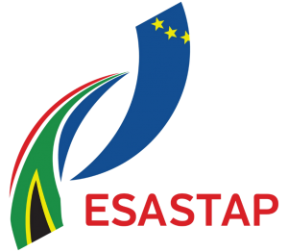

Report on use of DSI - COST seed funding

*NB: Report should be submitted seven (7) days after the travel

Applicants Details
Organisation
Name of Applicant
Student & ID numbers
Email Address
Tel.
Mobile number
Name of COST Activity
Host Country
Duration of travel
Report Date
Date of submission of report
South African participants
Purpose of the COST Activity
Key outcomes of discussions
Lessons learnt
The way forward, follow-ups and time frames
Appendices
This report should be accompanied by a budget breakdown of each activity and copies of proof of expenditure, certified by your financial officer.

…………………………………
Date:

NOTE: The personal information submitted by applicants shall be solely used for purposes of assessing the requests for COST seed funding received by the Department of Science and Innovation (DSI).

In terms of section 11 (1) of the Protection of Personal Information Act, 2013 (POPIA), by submitting the application, the applicant consents to the processing of personal information by the DSI.

All the information submitted shall be used for the purpose stated above, as mandated by POPIA. The DSI undertakes to secure the integrity and confidentiality of personal information in its possession or under its control by taking appropriate, reasonable technical and organisational measures to prevent loss of damage to or unauthorised destruction of personal information and unlawful access to or processing of personal information.

